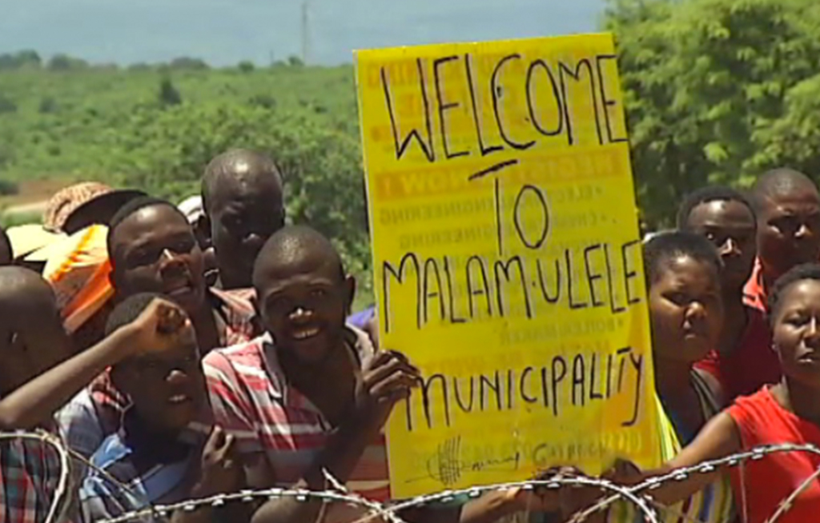
How Thulamela Underdeveloped Malamulele
by Bantsi Makhandeni

